Day 26 – 22nd August- 113195064 - Bondili Bhavya Charitha
Strategy Design and Command Pattern are Very Important Topics.

TASK:1
interface DifficultyLevel {
void startGame();
}
class EasyLevel implements DifficultyLevel {
public void startGame() {
System.out.println("Starting game at EASY level.");
}
}
class MediumLevel implements DifficultyLevel {
public void startGame() {
System.out.println("Starting game at MEDIUM level.");
}
}
class DifficultLevel implements DifficultyLevel {
public void startGame() {
System.out.println("Starting game at DIFFICULT level.");
}
}
class ChessGame {
private DifficultyLevel level;

public ChessGame(DifficultyLevel level) {
this.level = level;
}

public void setDifficultyLevel(DifficultyLevel level) {
this.level = level;
}

public void startChessGame() {
level.startGame();
}
}
public class Main {
public static void main(String[] args) {
System.out.println("Strategy Design Pattern - Behavioral Design Pattern");

ChessGame game = new ChessGame(new EasyLevel());
game.startChessGame();

game.setDifficultyLevel(new MediumLevel());
game.startChessGame();

game.setDifficultyLevel(new DifficultLevel());
game.startChessGame();
}
}

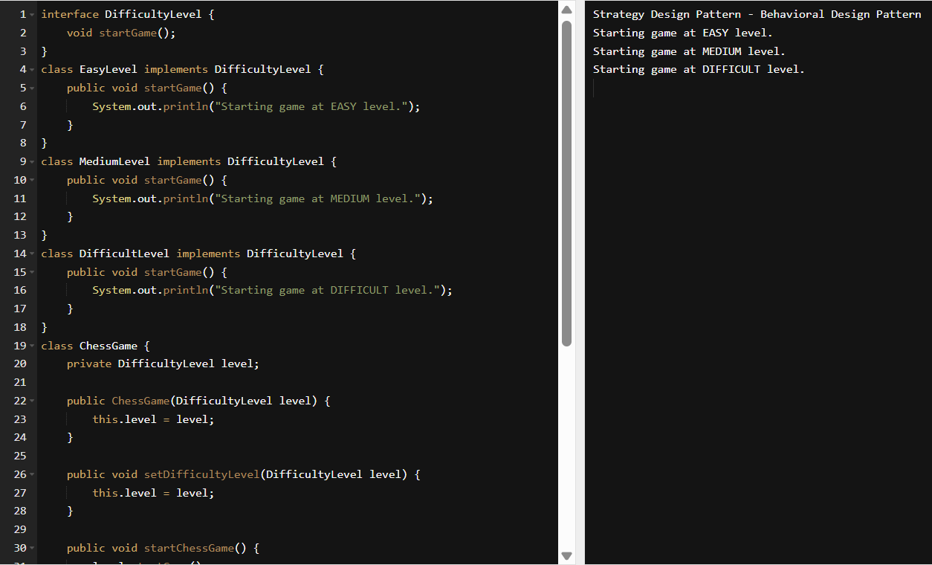

TASK:2 - What do you know about Design Work Flow.
Design workflow refers to the structured process designers follow to move from concept to completion. It typically begins with understanding user needs and defining the problem. Next comes the research, ideation, and creating possible solutions. Designers then prototype and test their ideas for usability and effectiveness. Feedback is gathered and iterations are made to refine the design. Finally, the solution is delivered for implementation or production.

Task:3 - What do you know Persistent objects.
Persistent objects are instancing whose state is stored beyond the lifetime of the application. They are typically saved in databases, files, or other storage systems. Unlike transient objects, they retain data between sessions and can be retrieved later. Persistence is often managed through Object-Relational Mapping (ORM) frameworks like Hibernate or JPA. These objects are crucial for maintaining long-term data integrity and consistency. In OOAD, they bridge the gap between in-memory models and permanent storage.
Task:4
Which of the following components is not typically part of the Command pattern?
a) Invoker
b) Receiver
c) Abstract Factory
d) Command (interface/abstract class)

Task 5:
What role does the Invoker play in the Command pattern?
a) It knows how to perform the operations associated with a request.
b) It encapsulates the request as an object.
c) It asks the command to carry out the request.
d) It defines the interface for executing an operation.

Task 6:
A key benefit of using the Command pattern is its ability to support:
a) Lazy initialization
b) Undo/Redo functionality
c) Singleton instance creation
d) Compile-time polymorphism

Task 7:
In the Strategy pattern, what role does the "Context" play?
A. It defines the interface for the algorithms.
B. It implements a specific algorithm.
C. It maintains a reference to a Strategy object and delegates the task to it.
D. It creates the Concrete Strategy objects.
Task 8:
In which of the following mechanisms, types of all variables and expressions are fixed at compilation time.
a) Strong Typing
b) Weak Typing
c) Static Binding/ early binding
d) Dynamic Binding/ late binding

Task 9:
In which pattern does a class represent the functionality of another class, providing a simplified interface to a complex subsystem?
a) Decorator Pattern
b) Facade Pattern
c) Proxy Pattern
d) Composite Pattern

Task 10:
Which of the following statements about Persistence is correct?
a) It is the enforcement of the class of an object, such that objects of different types may not be interchanged, or at the most they may be interchanged only in very restricted ways.
b) It is the property of an object through which its existence transcends time and/or space.
c) It is the property that distinguishes an active object from one that is not active.
d) All of the mentioned

Task 11:
What is that concept in type theory in which a single name may denote objects of many different classes that are related by some common super class referred to ______
a) Monomorphism
b) Type Checking
c) Polymorphism
d) Generalization

Task 12:
Which of the following patterns is used to create a single instance of a class and provide a global point of access to it?
a) Factory Pattern
b) Singleton Pattern
c) Builder Pattern
d) Prototype Pattern

Task 13:
The Adapter pattern is a type of ______ pattern.
a) Creational
b) Structural
c) Behavioral
d) Concurrency

Task 14:
Which design pattern defines a one-to-many dependency between objects so that when one object changes state, all its dependents are notified and updated automatically?
a) Strategy Pattern
b) Command Pattern
c) Observer Pattern
d) Mediator Pattern

Task 15:
The Model-View-Controller (MVC) is an example of a ______ pattern.
a) Creational
b) Structural
c) Behavioral
d) Architectural

Task 16:
Class name DManager

Add , remove , retrieve.. Methods (list)

→ Declare private static variable ..- type Dmanager - make sure it holds singleton instance
→ create private constructor to prevent direct instantiation of class
→ create instance..
→ throw an illegalStaticException , create singleton instance if not created .. use getInstance()
→ public static synchronized method – getInstance()
→ return existing instance..
→ create a new instance if doesnot exist..

In the thread safe list management:

→ declare a private variable
→ initialize the list inside the constructor using new..
→ also implement public sync methods
→ addItem
→ removeitem
→ list

import java.util.ArrayList;
import java.util.Collections;
import java.util.List;

public class DManager {

// Singleton instance
private static DManager instance;

// Thread-safe list
private List<String> items;

// Private constructor to prevent direct instantiation
private DManager() {
if (instance != null) {
throw new IllegalStateException("Instance already created. Use getInstance() method.");
}
items = Collections.synchronizedList(new ArrayList<>());
}

// Public synchronized method to get the singleton instance
public static synchronized DManager getInstance() {
if (instance == null) {
instance = new DManager();
}
return instance;
}

// Synchronized method to add item
public synchronized void addItem(String item) {
items.add(item);
System.out.println("Added: " + item);
}

// Synchronized method to remove item
public synchronized void removeItem(String item) {
if (items.remove(item)) {
System.out.println("Removed: " + item);
} else {
System.out.println("Item not found: " + item);
}
}

// Synchronized method to retrieve list
public synchronized List<String> list() {
return new ArrayList<>(items); // Return a copy to avoid external modification
}

// Optional: for demonstration
public static void main(String[] args) {
DManager manager = DManager.getInstance();
manager.addItem("Task1");
manager.addItem("Task2");
manager.removeItem("Task1");

System.out.println("Current Items: " + manager.list());
}
}

